***How to create cognito token using postman***

1. In the postman, go to Authorisation and select **OAuth 2.0** in **Type**. 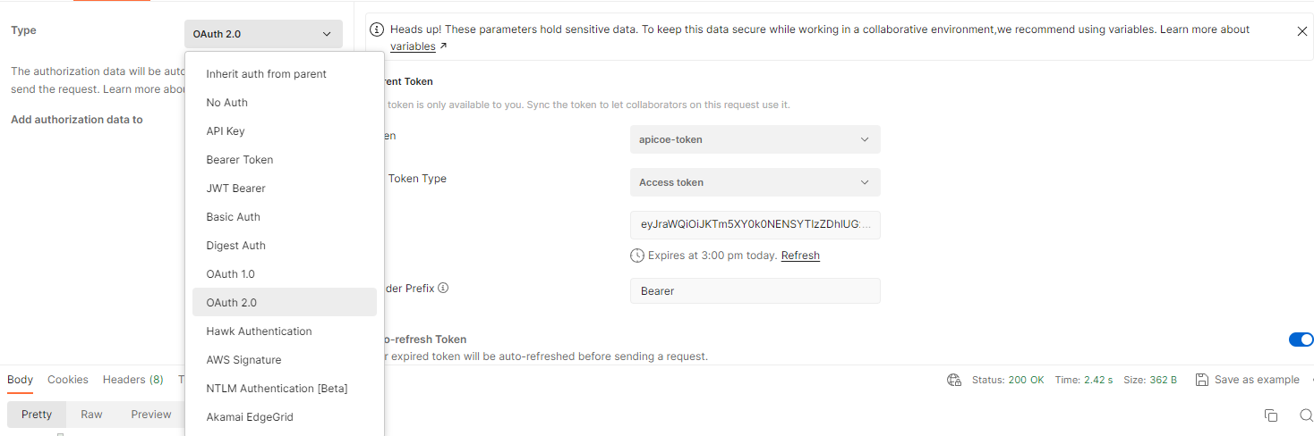
2. Then give the token a name **apicoe-token**  in this case.
3. Select **Authorization Code** for **Grant Type.**
4. Then in **Callback URL**, use the URL as provided in the Hosted UI in cognito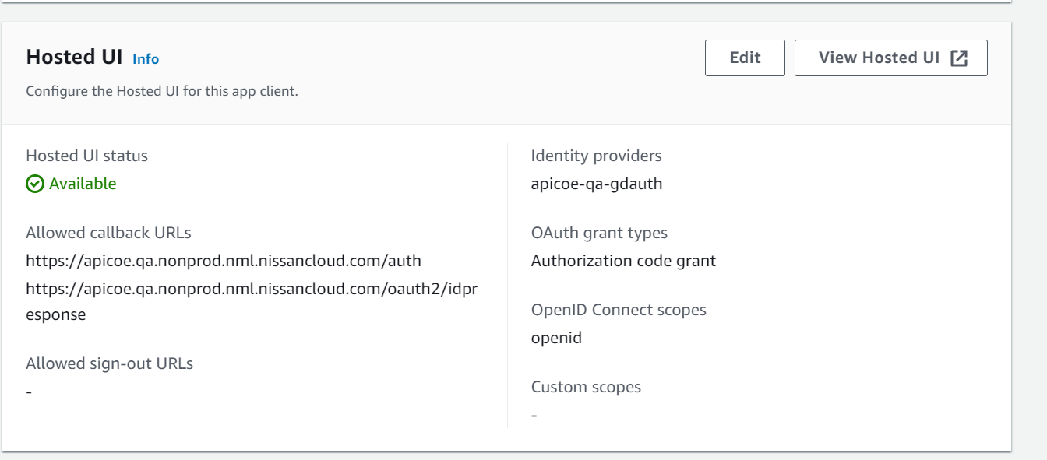
5. In **Auth URL**, the URL format is **cognito_domain/oauth2/authorize.**
6. In **Access Token URL**, the URL format is **cognito_domain/oauth2/token.** 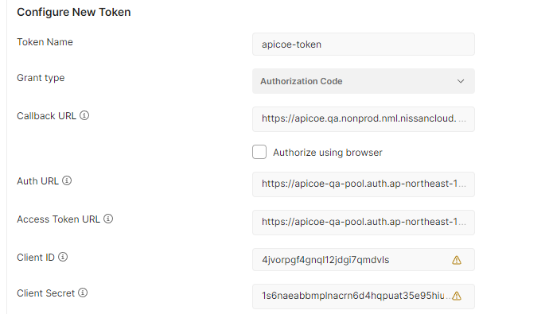
7. Provide the **Client ID** and **Client Secret** as mentioned in **App Client Information** 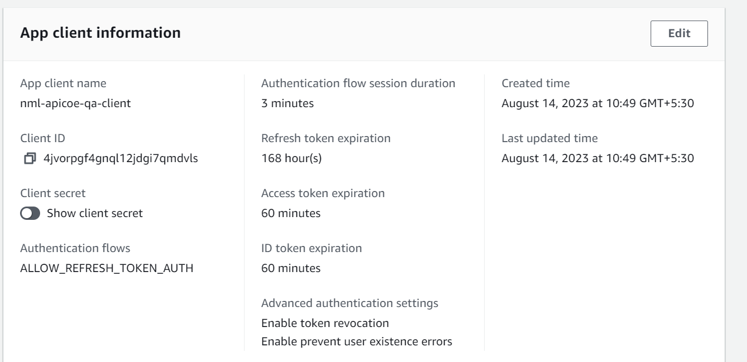
8. For the **Scope**, give the value as per the cognito settings, openid in this case.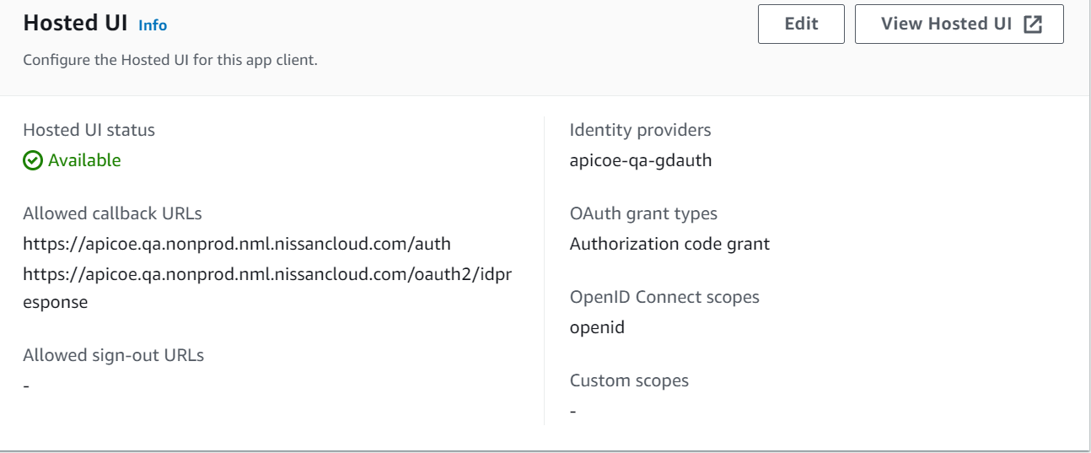
9. Then click on **Generate New Access Token**. 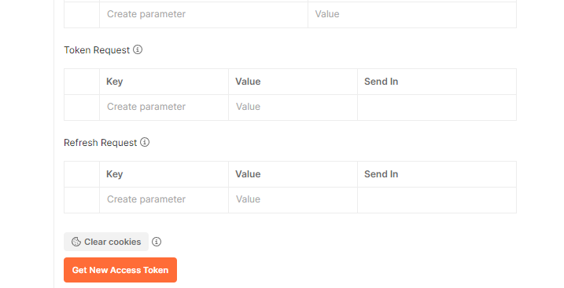
10. You will be redirected to the UI page where you need to sign in using your username and password. 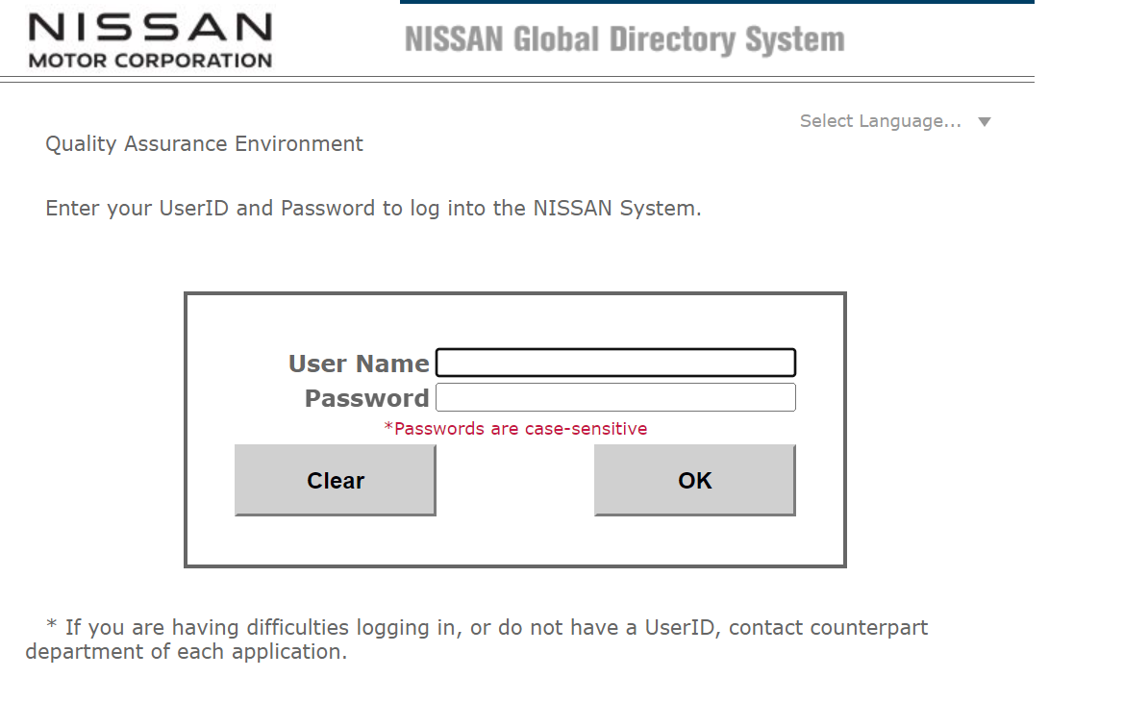
11. Then click on **OK**. The token will be generated.
12. Click on **Use Token** 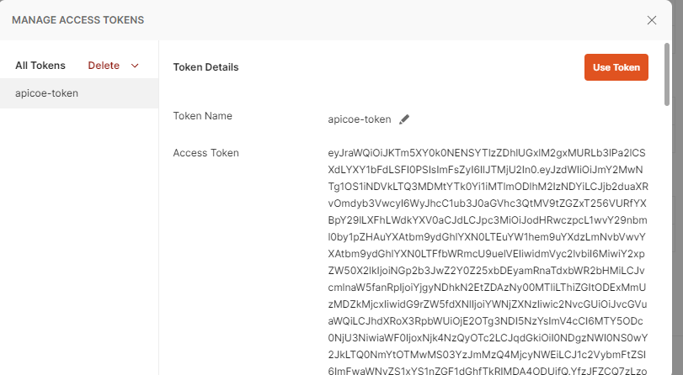
13. You can see this token in the Headers section of the request in postman.
14. Then click on send.